

Wider Professional Practice and Development in

Education and Training

1 | P a g e

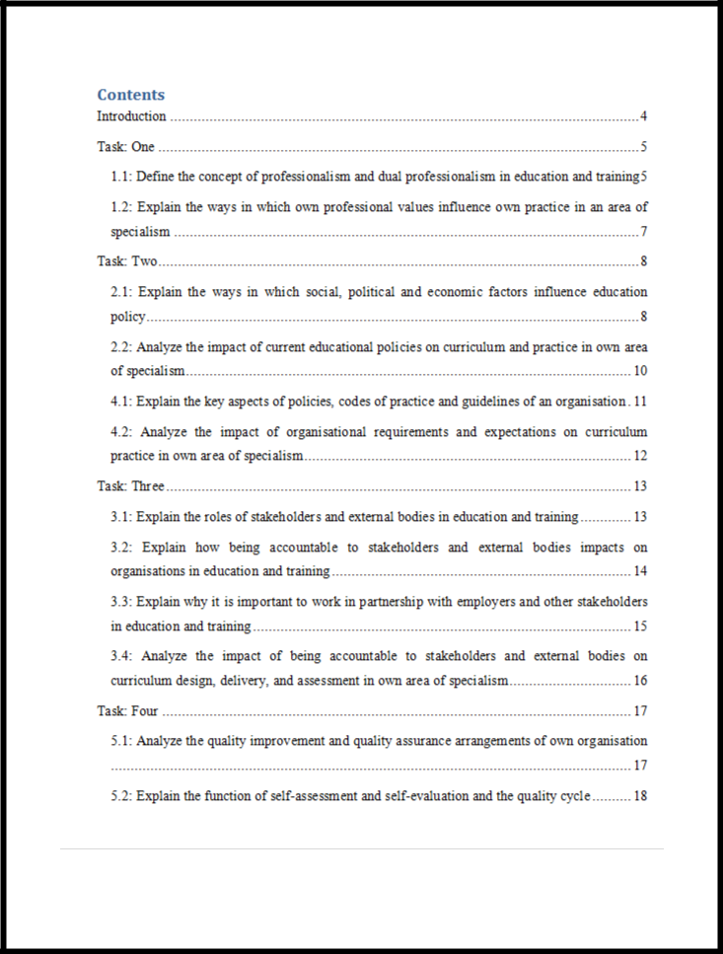

2 | P a g e

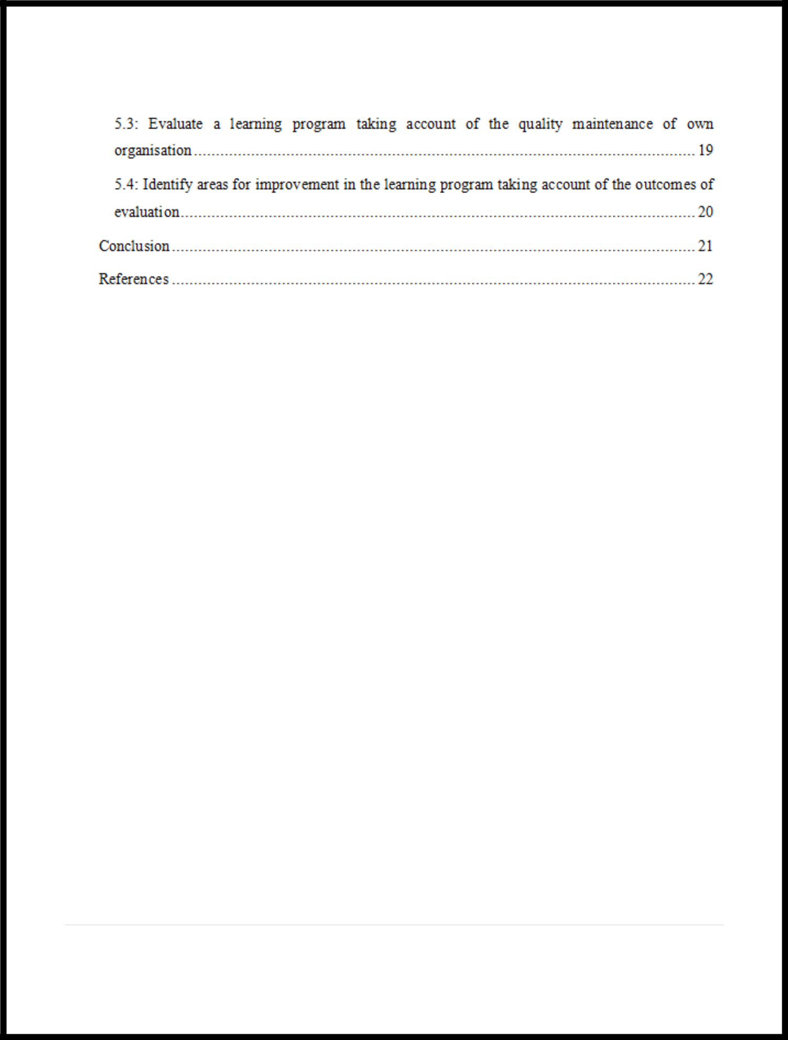

3 | P a g e

Introduction

It is essential for the organisation to have the skilled employees to operate the organisation in an organized way and to achieve the goal of the organisation. The employees are able to provide the effective performance though enriching the knowledge and though developing the skills. As for this reason it is necessary to make sure the employees are able to enrich the knowledge and develop the skills. To enrich the knowledge and to develop the skill it is necessary to have the effective learning system. To ensure the effective learning system it is essential to consider the effective education policy. In this report the researcher is going to express different ways of effective learning and different ways of developing effective education policy. The effective learning and education policy is essential for the organisation to achieve the goal of the organisation successfully.

4 | P a g e

Task: One

1.1: Define the concept of professionalism and dual professionalism in education and training

Professionalism

Professionalism is considered as the knowledge and skill of the individual that the individual apply in completing the specific tasks at the professional field. The learner develop the knowledge and skill though diriment learning and training to develop the professional career of the individual. In short professionalism is considered as the skills that are essential to build the professional career of the individual.

There are different factors and elements are necessary in professionalism. These are highlighted and discussed below.

Autonomy: Autonomy is the process through which the individual is able to identify the required skills and knowledge to complete the specific tasks (Forrest, 2013). Then the individual apply the required skill and successfully complete the specific task.

Code of Conduct: It is necessary for the individual to be ethical at the professional field. Code of conduct will help the individual to be ethical at the professional field.

Roles and Responsibilities: This will help to get clear idea about the role and responsibilities of the individual. Then the term will motivate the individual to play the role and to complete the responsibilities successfully.

Concepts of Leadership: It is essential to have the knowledge and to have the leadership skill to lead the team successfully. The concept of leadership will develop the leadership skill and will allow the individual to lead the team successfully.

National Bodies: National bodies will perform to provide different training and learning to the individual that the individual will be able to develop the skill and enrich the knowledge successfully.

5 | P a g e

Dual Professionalism

The individual who is able to complete the tasks of different professional field is considering as the dual professionalism. The individual with dual professionalism used to have knowledge and skill about different professional tasks. As for this reason the individual is considered as the dual professionalism.

In dual Professionalism the Membership Bodies

Institute for Learning: The duty of the institute of learning is to provide training and learning that the individual will be able to enrich knowledge and though applying the knowledge the individual successfully will be able to improve the skills (Forrest, 2013).

Qualified Teacher Learning and Skills Status (QTLS): It is essential to have the qualified teacher as the qualified teacher will help to get the effective knowledge and though the knowledge the individual will be able to develop the skills.

National Professional Standards: This will help to maintain the standard of national professionals and as for this the individual will be able to have the effective knowledge.

6 | P a g e

1.2: Explain the ways in which own professional values influence own practice in an area of specialism

Meeting Organisational Policies and Procedures: It is essential to make sure that the policies and the procedures of the organisation are to be maintained properly. The trainers and the learners have to take the responsibility to maintain the policy and procedure in well manner.

Audit of Competence: The regular audit will help to ensure the effective learning for the learners. It will help to provide the effective knowledge to the learners.

Promoting Quality Teaching: It is essential to make sure that the quality teaching is promoting. The quality teaching will help to get the effective knowledge and to have the development in skills (Bryant-Jefferies, 2001).

The Expectation for High Standards: The learner has the expectation of getting high standard learning. It is essential to fill the expectations of the learner though providing high standard learning.

Establishing and Sharing Best Practice: The best practice will help to grow the knowledge of the learner. As for this reason it is essential to establish and share the best practice in well manner.

Updating Specialist Knowledge and Skills: The organisation need to develop the learning process as it will help to update the knowledge and skills of the individual successfully.

Engaging CPD Opportunities: It is essential to make sure that the individual is able to have the continuous development. The continuous development will help to develop the knowledge and skill of the learner in regular basis.

7 | P a g e

Task: Two

2.1: Explain the ways in which social, political and economic factors influence education policy

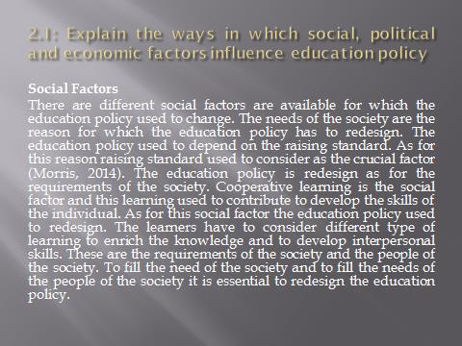

Social Factors

There are different social factors are available for which the education policy used to change. The needs of the society are the reason for which the education policy has to redesign. The education policy used to depend on the raising standard. As for this reason raising standard used to consider as the crucial factor (Morris, 2014). The education policy is redesign as for the requirements of the society. Cooperative learning is the social factor and this learning used to contribute to develop the skills of the individual. As for this social factor the education policy used to redesign. The learners have to consider different type of learning to enrich the knowledge and to develop interpersonal skills. These are the requirements of the society and the people of the society. To fill the need of the society and to fill the needs of the people of the society it is essential to redesign the education policy.

8 | P a g e



Political Factors

Political factors are the reason for which the education policy used to redesign. A country is able to have the growth as for the political reason and for the economic growth the education policy of a country used to redesign. The central authority or the education board of a country takes different steps to redesign the education policy of the country. This step used to effect on the education system of the country. Different national events are the cause of the redesign of the education policy. To develop the skills of the individual the government used to take attempt to change the education policy. These attempts ate considered as the political attempt and as for these attempts the education policy of a country used to redesign.

Economic Factors

The learner needs to have the development in their knowledge and skills. Except this the learner need to fill the skill gap and for this reason it is necessary to have the change in the education policy (Nolan and Pritchatt, 2006). To have the economic growth it is essential to have the skilled employees and as for this it is essential to have the change in the education policy.

Education policy can also be changed due to the impact of globalization. To maintain the current 9 | P a g e

standard educational organisation is providing better skills and training to their learners. It is necessary to ensure that the individual is able to have the proper knowledge about the process of investment and to ensure that it is essential to redesign the education policy.

10 | P a g e

2.2: Analyze the impact of current educational policies on curriculum and practice in own area of specialism



The Impact of Current Educational Policies on Curriculum

There different effects are available on the current education policy as for the impact of curriculum and policy. Curriculum used to have the impact on the functions of training and the educational content. It is essential to make sure that the standard content is considered as it will help to maintain the standard of the education. The effective curriculum framework will help to maintain the standard of the curriculum. The learners will be able to have the learning in an organized way (Jones-Devitt and Smith, 2007). The system will help to develop the education system and the learners will be able to have the effective learning. Vocational learning is the education system that will help the learner to have the development on their skills practically. This knowledge and skill will help the learner to have the effectiveness in their professional life.

The Impact of Current Educational Policies on Practice

11 | P a g e

The current educational policies used to have the huge impact on the practice. The practice used to have the direct impact on the process of the education. The practice used to help the learner to maintain the education standard. The practice will help to ensure the standard education and as for the standard education the learners will be able to enrich the effective knowledge and the effective knowledge will help to have the improvements on the skills of the learners. Practice will motivate to use different tools and the tools will contribute to develop the skills and the performance of the learners. As like, key performance indicator and benchmarking are the tools and though considering the tools the learner will be able to have the improvement on the skills and the performance of the learners. The impact of the current education policies on the practice is that it will help the learner to have the development in their skill and in their performance.

12 | P a g e

4.1: Explain the key aspects of policies, codes of practice and guidelines of an organisation
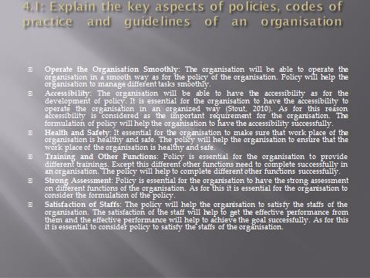

Operate the Organisation Smoothly: The organisation will be able to operate the organisation in a smooth way as for the policy of the organisation. Policy will help the organisation to manage different tasks smoothly.

Accessibility: The organisation will be able to have the accessibility as for the development of policy. It is essential for the organisation to have the accessibility to operate the organisation in an organized way (Stout, 2010). As for this reason accessibility is considered as the important requirement for the organisation. The formulation of policy will help the organisation to have the accessibility successfully.

Health and Safety: It essential for the organisation to make sure that work place of the organisation is healthy and safe. The policy will help the organisation to ensure that the work place of the organisation is healthy and safe.

13 | P a g e

Training and Other Functions: Policy is essential for the organisation to provide different trainings. Except this different other functions need to complete successfully in an organisation. The policy will help to complete different other functions successfully.

Strong Assessment: Policy is essential for the organisation to have the strong assessment on different functions of the organisation. As for this it is essential for the organisation to consider the formulation of the policy.

Satisfaction of Staffs: The policy will help the organisation to satisfy the staffs of the organisation. The satisfaction of the staff will help to get the effective performance from them and the effective performance will help to achieve the goal successfully. As for this it is essential to consider policy to satisfy the staffs of the organisation.

14 | P a g e

4.2: Analyze the impact of organisational requirements and expectations on curriculum practice in own area of specialism
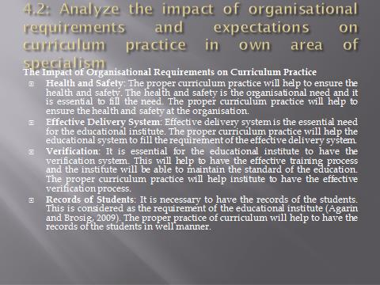

The Impact of Organisational Requirements on Curriculum Practice

Health and Safety: The proper curriculum practice will help to ensure the health and safety. The health and safety is the organisational need and it is essential to fill the need. The proper curriculum practice will help to ensure the health and safety at the organisation.

Effective Delivery System: Effective delivery system is the essential need for the educational institute. The proper curriculum practice will help the educational system to fill the requirement of the effective delivery system.

Verification: It is essential for the educational institute to have the verification system. This will help to have the effective training process and the institute will be able to maintain the standard of the education. The proper curriculum practice will help institute to have the effective verification process.

15 | P a g e

Records of Students: It is necessary to have the records of the students. This is considered as the requirement of the educational institute (Agarin and Brosig, 2009). The proper practice of curriculum will help to have the records of the students in well manner.

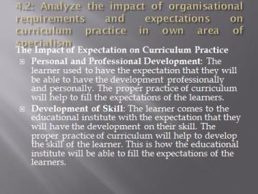

The Impact of Expectation on Curriculum Practice

Personal and Professional Development: The learner used to have the expectation that they will be able to have the development professionally and personally. The proper practice of curriculum will help to fill the expectations of the learners.

Development of Skill: The learner comes to the educational institute with the expectation that they will have the development on their skill. The proper practice of curriculum will help to develop the skill of the learner. This is how the educational institute will be able to fill the expectations of the learners.

16 | P a g e

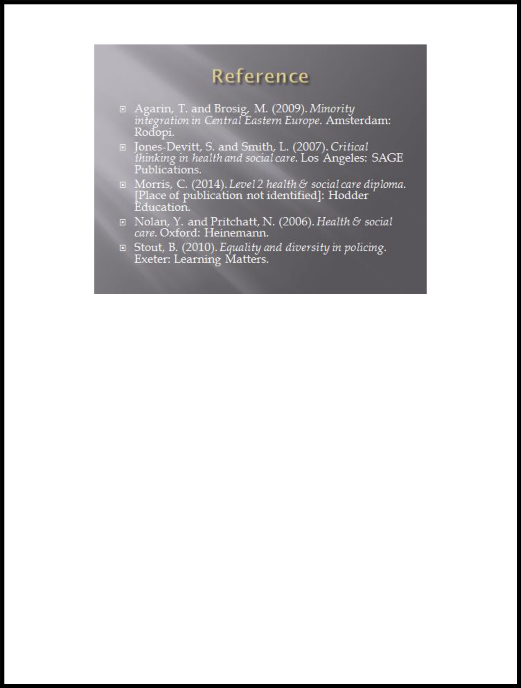

17 | P a g e

Task: Three

3.1: Explain the roles of stakeholders and external bodies in education and training

The Role of Stakeholders

External Customers: External customers affect the training program they can be viewed as the stakeholders.

Internal Staffs: It is essential to maintain the internal staffs of the organisation and the role of the stakeholders is to maintain the internal staffs that they would not be able to leave impact on the education and training process of the organisation.

Senior Management Body: The senior management body is the stakeholder of the organisation and the play the role to develop the policy and the procedure of the education system.

Employees: It is necessary for the employees to develop the knowledge and skill though the education. As tit will help to develop their performance and though the effective performance they will be able to achieve the goal of the organisation (Stout, 2010).

The Role of External Bodies

Customer Support Program: This is the program that is maintained by the stakeholders to ensure that the organisation is able to satisfy the customers. The satisfaction of the customers will help to grow the business of the organisation.

IT Support: The stakeholder provide the IT support to develop the performance of the organisation. The developed performance will help the organisation to achieve the goal successfully.

Organisational Reputation: The stakeholder performs to maintain the reputation of the organisation. If the organisation fail to maintain the reputation then it will be impossible for the organisation to grow the business successfully.

18 | P a g e



19 | P a g e

3.2: Explain how being accountable to stakeholders and external bodies impacts on organisations in education and training

Help to Achieve the Target of the Organisation

Accountability will help the organisation to achieve the target of the organisation in an organized way. As for this reason it is essential for the organisation to consider accountability to achieve the goal of the organisation.

Qualified and Skilled Staffs

Accountability is the process that will help the organisation to have the qualified and skilled employees. The performance of the qualified and skilled employees will help the organisation to grow the business of the organisation successfully.

Clarity of Reporting

It is essential to make sure the report is able to provide the clear knowledge. Accountability will help the organisation to provide the clear report and to consider clarity in the report (Jones-Devitt and Smith, 2007).

National Vocational Standard

Accountability will help the organisation to maintain the standard of the national vocational training. It will help to provide the effective training and the effective training will help the organisation to have the effective development in the skills of the employees. As for this the employees will be able to provide the effective performance and though the effective performance the organisation will be able to achieve the goal successfully.

Responsiveness

It is essential to make sure the employees and the stakeholders of the organisation are responsiveness. The responsiveness is essential to complete different tasks of the organisation and to grow the business of the organisation successfully. The responsiveness will be increased though the contribution of accountability.

20 | P a g e

21 | P a g e

3.3: Explain why it is important to work in partnership with employers and other stakeholders in education and training

Partnership with Employer

To Achieve the Goal

It is essential to have the partnership with the employer to achieve the goal successfully. The partnership work will help to get the effective output and though the effective output the goal will be achieved successfully.

Best Workplace

It is essential to have the partnership to ensure the best workplace. The employer will help to provide the best work place and the friendly environment at the work place will be ensured by the employer. As for this reason it is essential to have the partnership with the employer.

Quality Program

It is essential to have the partnership with the employer to develop the quality program for the learners. The quality program will help to provide the effective knowledge to the learner and though applying the knowledge the learner will be able to develop the effective skill. As for this reason it is essential to have the partnership with the employer (Nolan and Pritchatt, 2006).

Partnership with Stakeholders

Collaborative Program

The collaborative program will help to provide the knowledge about different thing and as for this the learner will be able to develop the skill on different thing. To develop the collaborative program it is essential to have the partnership with the stakeholders.

Alternative Learning

It is essential to provide the alternative learning to the learners. This will help to get knowledge about different alternative things. To provide the alternative learning it is essential to have the partnership with the stakeholders.

22 | P a g e

23 | P a g e

3.4: Analyze the impact of being accountable to stakeholders and external bodies on curriculum design, delivery, and assessment in own area of specialism

Occupational Need

It is necessary to design a proper curriculum as it will help to fill the needs of occupational. The occupational needs are necessary to fill to achieve the target appropriately. As for this it is necessary to make sure that the curriculum is designed in well manner.

National Standard

It is essential to make sure that the curriculum will be designed properly. It will help to maintain the national standard. It is necessary to maintain the national standard to make sure the learners are able to get the effective knowledge. As for this it is necessary to make sure that the curriculum is designed in well manner.

Delivery and Assessment Process

It is necessary to make sure the effective delivery and assessment process. It will help to enrich the knowledge of the individual. The enriched knowledge of the individual will help to develop the skills of the individual. With the developed skill the individual will be able to ensure the effective performance for the organisation (Morris, 2014). As for this it is necessary to make sure the effective delivery and assessment process. The appropriate design of curriculum will help to ensure the effective delivery and assessment process.

Flexible Learning System

To provide the appropriate learning it is necessary to make sure that the learner is able to get the learning in a flexible way. It will help the learner to understanding the learning in proper way and the learner will be able to develop the knowledge in well manner. The flexible learning system is ensured by the appropriate design of curriculum. As for this reason it is necessary to make sure to design the appropriate curriculum.

24 | P a g e

Task: Four

5.1: Analyze the quality improvement and quality assurance arrangements of own organisation
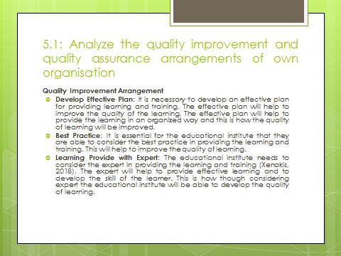

Quality Improvement Arrangement

Develop Effective Plan: It is necessary to develop an effective plan for providing learning and training. The effective plan will help to improve the quality of the learning. The effective plan will help to provide the learning in an organized way and this is how the quality of learning will be improved.

Best Practice: It is essential for the educational institute that they are able to consider the best practice in providing the learning and training. This will help to improve the quality of learning.

Learning Provide with Expert: The educational institute needs to consider the expert in providing the learning and training (Xenakis, 2018). The expert will help to provide effective learning and to develop the skill of the learner. This is how though considering expert the educational institute will be able to develop the quality of learning.
25 | P a g e

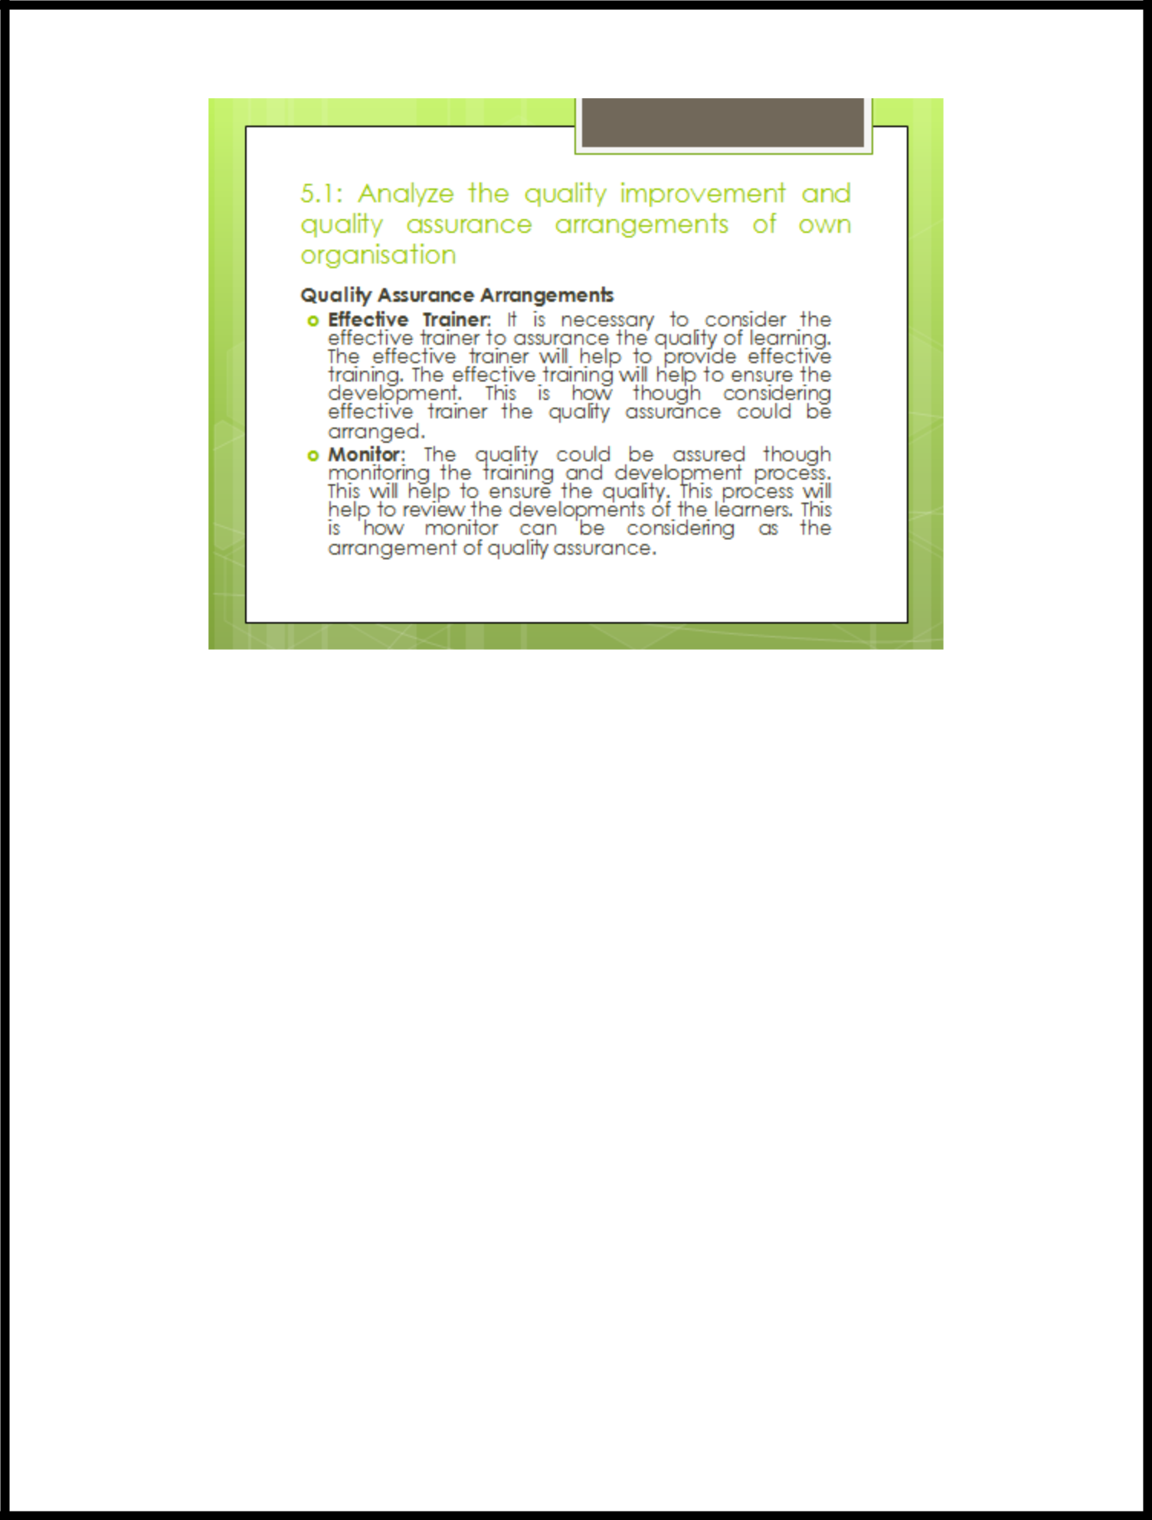

Quality Assurance Arrangements

Effective Trainer: It is necessary to consider the effective trainer to assurance the quality of learning. The effective trainer will help to provide effective training. The effective training will help to ensure the development. This is how though considering effective trainer the quality assurance could be arranged.

Monitor: The quality could be assured though monitoring the training and development process. This will help to ensure the quality. This process will help to review the developments of the learners. This is how monitor can be considering as the arrangement of quality assurance.

26 | P a g e

5.2: Explain the function of self-assessment and self-evaluation and the quality cycle

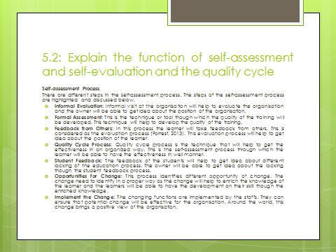

Self-assessment Process

There are different steps in the self-assessment process. The steps of the self-assessment process are highlighted and discussed below.

Informal Evaluation: Informal visit at the organisation will help to evaluate the organisation and the owner will be able to get idea about the position of the organisation.

Formal Assessment: This is the technique or tool though which the quality of the training will be developed. This technique will help to develop the quality of the training.

Feedback from Others: In this process the learner will take feedback from others. This is considered as the evaluation process (Forrest, 2013). This evaluation process will help to get idea about the position of the learner.

Quality Cycle Process: Quality cycle process is the technique that will help to get the effectiveness in an organized way. This is the self-assessment process through which the learner will be able to have the effectiveness in well manner.
27 | P a g e

Student Feedback: The feedback of the students will help to get idea about different lacking of the education process. The owner will be able to get idea about the lacking though the student feedback process.

Opportunities for Change: This process identifies different opportunity of change. The change need to identify in a proper way as the change will help to enrich the knowledge of the learner and the learners will be able to have the development on their skill though the enriched knowledge.

Implement the Change: The changing functions are implemented by the staffs. They can ensure that potential change will be effective for the organisation. Around the world, this change brings a positive view of the organisation.

28 | P a g e

5.3: Evaluate a learning program taking account of the quality maintenance of own organisation
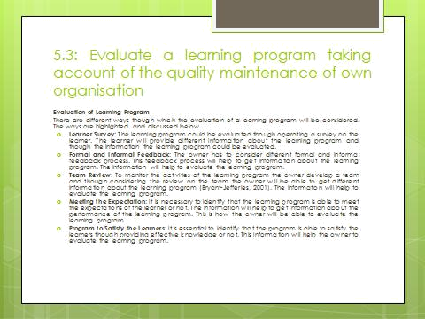

Evaluation of Learning Program

There are different ways though which the evaluation of a learning program will be considered.

The ways are highlighted and discussed below.

Learner Survey: The learning program could be evaluated though operating a survey on the learner. The learner will provide different information about the learning program and though the information the learning program could be evaluated.

Formal and Informal Feedback: The owner has to consider different formal and informal feedback process. This feedback process will help to get information about the learning program. The information will help to evaluate the learning program.

Team Review: To monitor the activities of the learning program the owner develop a team and though considering the review on the team the owner will be able to get different information

29 | P a g e

about the learning program (Bryant-Jefferies, 2001). The information will help to evaluate the learning program.

Meeting the Expectation: It is necessary to identify that the learning program is able to meet the expectations of the learner or not. The information will help to get information about the performance of the learning program. This is how the owner will be able to evaluate the learning program.

Program to Satisfy the Learners: It is essential to identify that the program is able to satisfy the learners though providing effective knowledge or not. This information will help the owner to evaluate the learning program.

30 | P a g e

5.4: Identify areas for improvement in the learning program taking account of the outcomes of evaluation
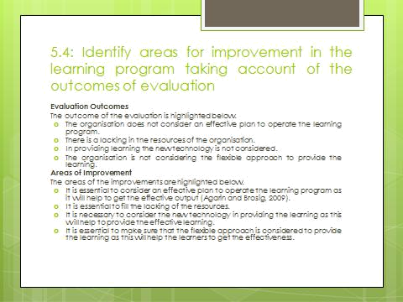

Evaluation Outcomes

The outcome of the evaluation is highlighted below.

- The organisation does not consider an effective plan to operate the learning program.

- There is a lacking in the resources of the organisation.

- In providing learning the new technology is not considered.

- The organisation is not considering the flexible approach to provide the learning.

Areas of Improvement

The areas of the improvements are highlighted below.

- It is essential to consider an effective plan to operate the learning program as it will help to get the effective output (Agarin and Brosig, 2009).

- It is essential to fill the lacking of the resources.

31 | P a g e

- It is necessary to consider the new technology in providing the learning as this will help to provide the effective learning.

- It is essential to make sure that the flexible approach is considered to provide the learning as this will help the learners to get the effectiveness.
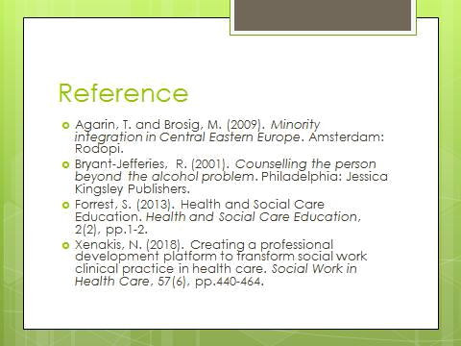

32 | P a g e

Conclusion

It is essential for the organisation to have the skilled and professional employees to grow the business of the organisation and to achieve the goal of the organisation. The above discussion express that the skill and the knowledge of the employees depend on the learning process. The effective learning process and education policy will help the organisation to get skilled employees and the skilled employees will help to get the effective performance. This is how though ensuring effective performance the organisation will be able to achieve the goal successfully.

33 | P a g e

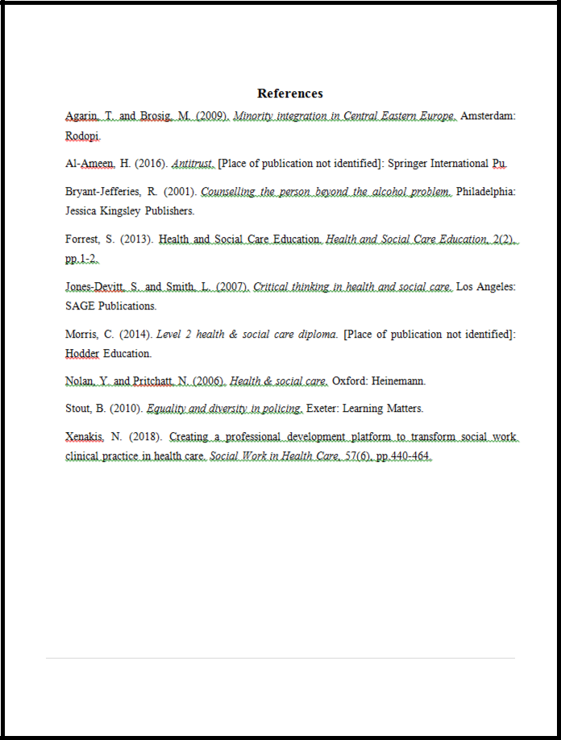

34 | P a g e

